First and last nama : Abdelmajid Mallouk
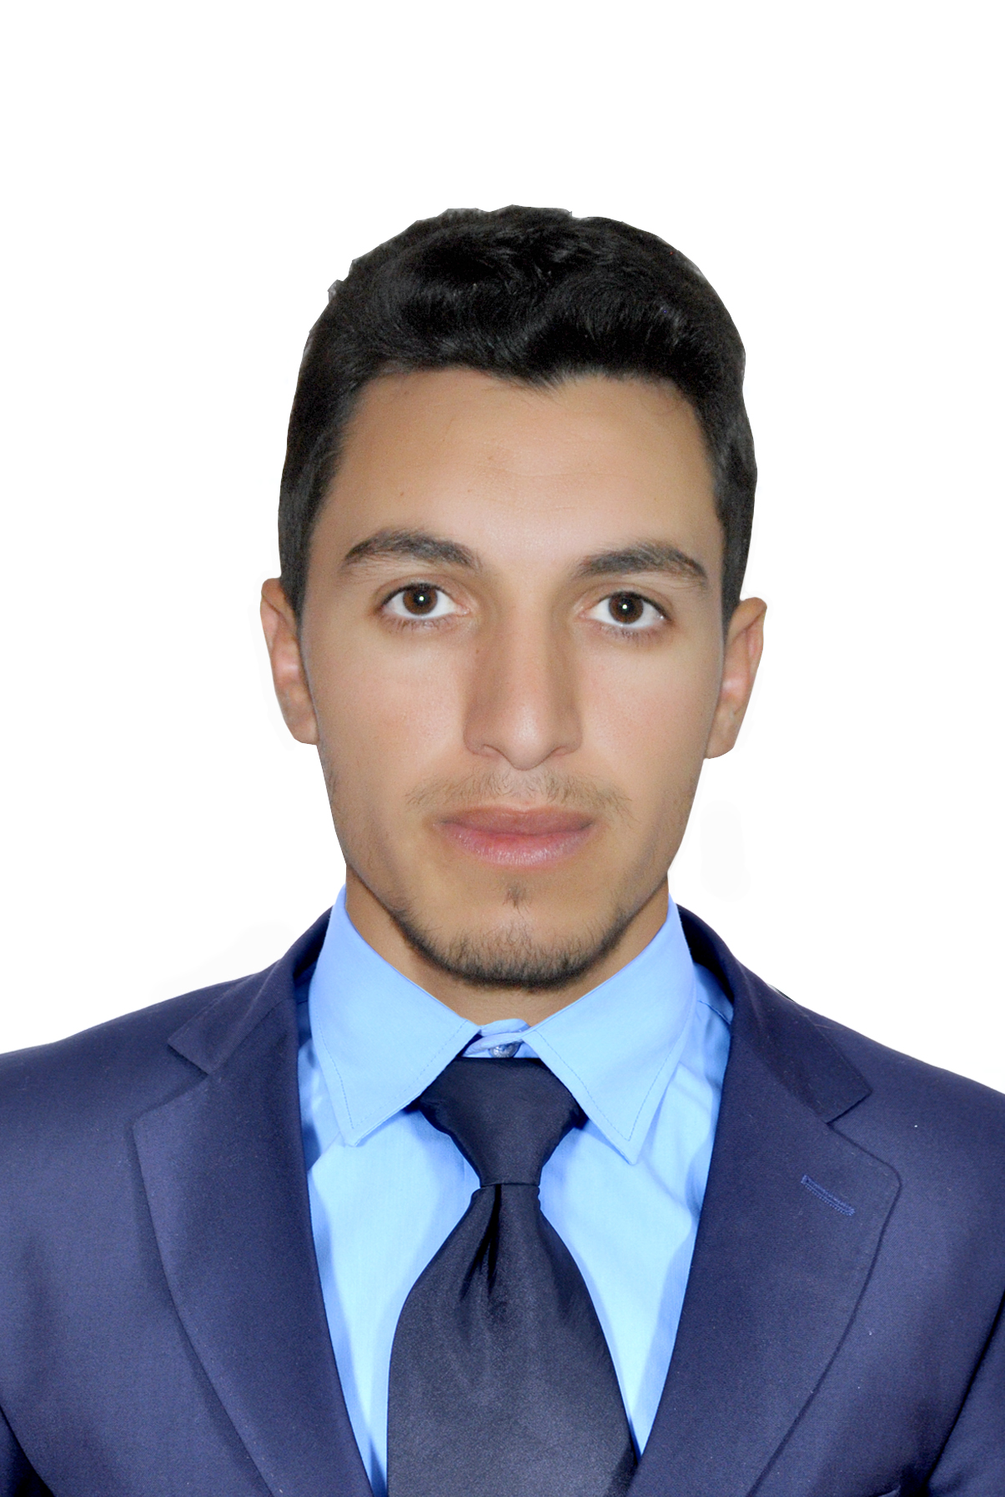
Address : Hay Saada rhahla khemisset
NIC : X341230
Mobile phone : 06 40452851
E-mail : abdelmajid90mallouk@gmail.com

DIPLOMAS AND TRAINING :

Bachelor’s degree 2015
-Modern letter

Drive’s License category (B) 2015

ITA
Technician
-business accountant 2012/2014

Association Ajji/Dell
Formation
-Informatique 2014

PROFESSIONAL EXPERIENCES :

Fiduciaries
Training course April 2014
Internship experience January 2015/ March 2017
-General Accounting
-Classification folders
-Entering sales and purchasing invoices
-Declaration tva
-Paying Technique
-The Bank and the Caisse
-Constitution of companies
-The Cnss

SKILLS :

Inventory management rules Ensuring the administrationes of supervision
Shelving techniques Assist the superviser
Sales techniques Word, Excel

LANGUAGES :

 Arabe : Mother Tongue

 Fransh : Good

 English : Good

HOBBIES :

- travel , Internet , Football , Reading and Swimming.

